*Workday@Yale*

# People Hub Release Note – August 18’th 2017

|  |  |
| --- | --- |
| **Incidents/Enhancements** | **Permanent Solution** |
| 1. Incident - INC1018809   State code has international state code | The following attributes are expected to only have US state codes:   * Grad_Student_State * Yale_Station_Student_State * Mail_Stop_Address_State * Home_Address_State_Code * Work_Address_State   Added additional logic in People Hub to replace international state codes with Null. |
| 1. Incident - INC1022967   Prox Number was missing from IDR feed to People Hub | IDR has fixed the issue. People Hub is getting Prox_Number for active ID Cards. |
| 1. Incident - INC1031132   New UPI’s when added via Grouper or by change in ABAC affiliation was not reflected in the YUPH_PEOPLE_GENERAL_HIST_RSET_V | Fixed the bug in People Hub to address the issue. Any newly added UPI via Grouper or by change in ABAC affiliation will be visible in YUPH_PEOPLE_GENERAL_HIST_RSET_V. |
| 1. Incident - INC1032163   UPI available in Workday but was missing from the IDR feed to People Hub | IDR has fixed the issue. People Hub is getting the missing identities from IDR. |
| 1. Incident - INC1044054   Manage name and UPI were not matching in the People Hub views | When manager was changed in workday, People hub didn’t get updated correctly. Fixed the issue in People Hub. |
| 1. People Hub Enhancement – HP ALM 6001   Add multiple dependency check:   * Extract data from Workday only after B to A copy is successfully completed. * Load stage table only after successful extraction of data from Workday. * Load DV table only after successful extraction of data from IDR. | Migrated the change to Production. |

# Upcoming Changes

1. There is a decision to remove SSN and gender from Sponsored Identity system and IDR. As a result, People Hub will not have SSN and gender for Sponsored Identities. This change is now in People Hub test and IDR has scheduled to move this change to production on August 24’th 2017.
2. People Hub Services have an upcoming release for the PeopleService, GetPeopleService, LimitedPeopleService, and SearchByIndividual web services. This release is currently available in TEST endpoints and PRODUCTION on 8/24. This is a minor version, which indicates that if you do not want any of the new features your existing code will continue to work. If you have time, please test your existing code in Test just to verify this change will not affect you. If existing code does not work, please open a ticket and assign to “Data Services and APIs” group.

**Change #1:** Add the possibility to get “Future State” data, which includes future hires and future rehires.

In order to get future data you will need to add “?includefuture=Y” parameter onto your endpoint. All existing requests will not need to be changed if you do not require future state data. **Note:** The logic for this is a current bug in the PeopleHub itself, so until that is resolved, rehires who are currently terminated will display in their future state in all views (this is how the data has been since July).

This is an example of the proposed data (Still WIP):

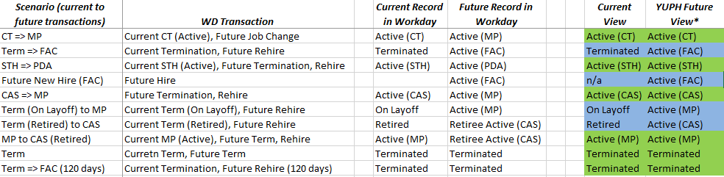

If you do not add includefuture=Y parameter by default you will get data in the “Current view” (This is what has always been seen), if you add the parameter you will get data as it is in the “Future View”.

**Example Future state requests:**

PeopleService: <https://gw-tst.its.yale.edu/soa-gateway/PeopleHub/v1/PeopleService?includefuture=Y>

GetPeopleService: <https://gw-tst.its.yale.edu/soa-gateway/PeopleHub/v1/GetPeopleService?includefuture=Y>

LimitedPeopleService: <https://gw-tst.its.yale.edu/soa-gateway/PeopleHub/v1/LimitedPeopleService?includefuture=Y>

SearchByIndividual:<https://gw-tst.its.yale.edu/soa-gateway/PeopleHub/v1/SearchByIndividual?netid=sl2393&includefuture=Y>

To help determine the source of your record, we have also added the field “View” to the “Status” section of the response data.  C=Current State, F=Future State

Example:

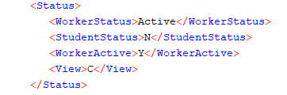

**Change #2:** This affects only PeopleService, GetPeopleService, and SearchByIndividual web services. We have added Mail Stop Address fields to the “Contact” response. This is the address for the mail stop code of the record.

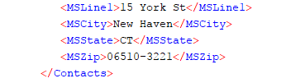

If you have additional questions or concerns, please contact [its.data.services@yale.edu](mailto:its.data.services@yale.edu).