Workday@Yale

People Hub Release Note – March 2017

Notes from prior People Hub releases can be found chronologically further down in this document. Use the navigation tabs on the left (or by clicking on the ‘View’ tab and selecting the ‘Navigation Pane’ box in the ‘Show’ area):
- February 2017
- December 2016
- November 2016
- September 2016

How to Connect
We have a test SQL server setup for impacted systems to connect and remediate their systems.
SQL Server Name: aw-dwtstdb-01.yu.yale.edu
Database: DV_PeopleHub
Login Username/Password: Once access form is approved, Service Now ticket should be submitted to create an account in PeopleHub.
The recommended connection method for people Hub is via a web service or JDBC/ODBC. Web service is preferred over JDBC/ODBC connection. You can also connect to People Hub via Microsoft SQL Server Management Studio for testing. While connecting with a service account to have Windows authentication satisfied, you need to Shift+Right Click on the tool and select ‘Run as different user’. This will prompt you to enter username and password and you could enter the service account and password provided for testing.

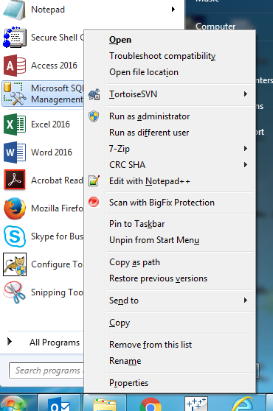

Source of Data
PeopleHub is currently getting data from two sources. They are as follows:
- IAM Identity Management System – Data is from IAM3. The data in IAM3 is last refreshed on:
  - Refreshed from Workday (Yale2) on August 2016
  - Refreshed from Banner (BAN3) on January 2017
  - Refreshed from Sponsored Identity System on January 2017
  - Refreshed Affiliates from Workday (Yale2) on August 2016
- Workday – Data is from Yale2 (SIT) instance. The data in Yale2 is last refreshed on:
  - Refreshed from production on 8/13/2016
Initial load is done on February 19’th, 2017 and then on March 7’th, 2017. Data will be loaded daily from IAM3 and Yale2 to People Hub from March 20’th onwards. Data load to People Hub is schedules to run from 6:00 AM to 10:00 AM. Data entered to Workday as of 5:45 PM pervious day will be available in People Hub at 10:00 AM.

Population
PeopleHub population include Students, Employees, Contingent Workers, Academic Affiliates and Sponsored Identity. PeopleHub has logic to include incremental loads. People Hub has:
- Student records from IDR
- Current last record of student workers from Workday
- Current last record of Academic Affiliates from Workday
- Current last record of Employees from Workday (Includes active, on leave, terminated, retired employees and future employees up to 90 days)
- Current last record of Contingents workers from Workday (Includes active, on leave, terminated, retired contingent workers and future contingent workers up to 90 days)
- Current last record of Sponsored Identities from IDR (No future Sponsored Identities)

Data Dictionary
PeopleHub currently has 357 attributes. This includes Identity data, addresses, student enrollment, position, job, compensation, academic appointments and affiliations. The split of attributes by source is as follows:
- 246 from Workday
- 111 from IDR (Identity System, it included all banner data we are getting for now)
Data dictionary is available in the Impacted Systems website:
Impacted Systems -> People Data Information -> Technical Information on People Hub Structure -> People Hub Data Dictionary
Mapping of Legacy People Data Attributes to post Workday R4 Data is also available in the Impacted Systems Website:
Impacted Systems -> People Data Information -> Overview of People Hub Documents, Requesting Access and Transition Information -> People Data Mapping Rules

Views
PeopleHub currently have the following views:
- YUPH_PEOPLE_GENERAL_CUR_RSET_V
- YUPH_PEOPLE_GENERAL_FUT_V
- YUPH_PEOPLE_GENERAL_ALL_V
- YUPH_PEOPLE_GENERAL_HIST_RSET_V
- YUPH_ACADEMIC_APPT_CUR_RSET_V
- YUPH_POSITIONS_CUR_RSET_V
- YUPH_ENROLLMENT_CUR_RSET_V
- YUPH_COST_CENTER_FLAT_V
- YUPH_COST_CENTER_HIER_V
- YUPH_ACADEMIC_UNIT_FLAT_V
- YUPH_SUPERVISORY_ORG_FLAT_V
Details documentation on these views are available in the Impacted Systems website:
Impacted Systems -> People Data Information -> Technical Information on People Hub Structure -> People Hub Integration Views

Security
PeopleHub has ABAC row level and column level security is implemented on views with names ending with RSET_V. This security is based on the access form filled out by each team. Row level security is based on specific affiliation of population requested in the access form. Column level security is based on the data grouping requested in the access form.

Issues Addressed in this Release
We have added, removed and modified several attributes in PeopleHub. Several issues reported as part of the testing are also addressed in this release. The issues raised by the impacted systems in ALM will be assigned back to the team to have it re-tested. Please re-test them and report the status back in ALM.
Detailed documentation on issues addressed in this release are available in Box folder:
PeopleHubIssuesAddresedForFebRel.xlsx –
https://workday.yale.edu/sites/default/files/files/PeopleHubIssuesAddresedForMarRel.xlsx

How to Report Defects
We are keeping track of defects using ALM. Please use the link below to connect to ALM. Use IE to connect.
https://hpalm.its.yale.edu/qcbin/start_a.jsp
To view defects:
Once logged in:
- Select Defects from left side tab
- Select Favorite - > Public -> PeopleHubPilot

To enter defects:
Once logged in:
- Select New Defect
- Specify the following:
  - Assigned To:
  - Type:
  - Priority:
  - Description:
  - Detected in Cycle: Releases -> PeopleHub -> Release 1 -> Pilot
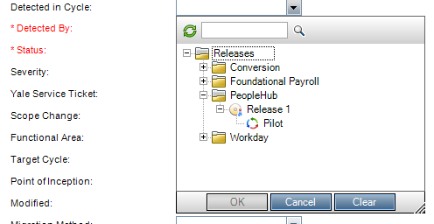
- Submit

People Hub Release Note – February 2017

How to Connect
We have a test SQL server setup for impacted systems to connect and remediate their systems.
SQL Server Name: aw-dwtstdb-01.yu.yale.edu
Database: DV_PeopleHub
Login Username/Password: Once access form is approved, Service Now ticket should be submitted to create an account in PeopleHub.
The recommended connection method for people Hub is via a web service or JDBC/ODBC. Web service is preferred over JDBC/ODBC connection. You can also connect to People Hub via Microsoft SQL Server Management Studio for testing. While connecting with a service account to have Windows authentication satisfied, you need to Shift+Right Click on the tool and select ‘Run as different user’. This will prompt you to enter username and password and you could enter the service account and password provided for testing.

Source of Data
PeopleHub is currently getting data from two sources. They are as follows:
- IAM Identity Management System – Data is from IAM3. The data in IAM3 is last refreshed on:
  - Refreshed from Workday (Yale2) on August 2016
  - Refreshed from Banner (BAN3) on January 2017
  - Refreshed from Sponsored Identity System on January 2017
  - Refreshed Affiliates from Workday (Yale2) on August 2016
- Workday – Data is from Yale2 (SIT) instance. The data in Yale2 is last refreshed on:
  - Refreshed from production on 8/13/2016

Initial load is done on February 13’th, 2017. Data will be loaded daily from IAM3 and Yale2 to People Hub from February 20’th onwards. Data load to People Hub is schedules to run from 6:00 AM to 10:00 AM. Data entered to Workday as of 5:45 PM pervious day will be available in People Hub at 10:00 AM.

Population
PeopleHub population include Students, Employees, Contingent Workers, Academic Affiliates and Sponsored Identity. PeopleHub has logic to include incremental loads. People Hub has:
- Student records from IDR
- Current last record of student workers from Workday
- Current last record of Academic Affiliates from Workday
- Current last record of Employees from Workday (Includes active, on leave, terminated, retired employees and future employees)
- Current last record of Contingents workers from Workday (Includes active, on leave, terminated, retired contingent workers and future contingent workers)
- Current last record of Sponsored Identities from IDR

Data Dictionary
PeopleHub currently has 354 attributes. This includes Identity data, addresses, student enrollment, position, job, compensation, academic appointments and affiliations. The split of attributes by source is as follows:
- 246 from Workday
- 108 from IDR (Identity System, it included all banner data we are getting for now)
Data dictionary is available in the Impacted Systems website:
Impacted Systems -> People Data Information -> Technical Information on People Hub Structure -> People Hub Data Dictionary
Mapping of Legacy People Data Attributes to post Workday R4 Data is also available in the Impacted Systems Website:
Impacted Systems -> People Data Information -> Overview of People Hub Documents, Requesting Access and Transition Information -> People Data Mapping Rules

Views
PeopleHub currently have the following views:
- YUPH_PEOPLE_GENERAL_CUR_RSET_V
- YUPH_PEOPLE_GENERAL_INCL_FUTURE_V
- YUPH_PEOPLE_GENERAL_HIST_RSET_V
- YUPH_ACADEMIC_APPT_CUR_RSET_V
- YUPH_POSITIONS_CUR_RSET_V
- YUPH_ENROLLMENT_CUR_RSET_V
- YUPH_COST_CENTER_FLAT_V
- YUPH_COST_CENTER_HIER_V
- YUPH_ACADEMIC_UNIT_FLAT_V
- YUPH_SUPERVISORY_ORG_FLAT_V
Details documentation on these views are available in the Impacted Systems website:
Impacted Systems -> People Data Information -> Technical Information on People Hub Structure -> People Hub Integration Views

Security
PeopleHub has ABAC row level and column level security is implemented on views with names ending with RSET_V. This security is based on the access form filled out by each team. Row level security is based on specific affiliation of population requested in the access form. Column level security is based on the data grouping requested in the access form.

Issues Addressed in this Release
We have added, removed and modified several attributes in PeopleHub. Several issues reported as part of the testing are also addressed in this release. The issues raised by the impacted systems in ALM will be assigned back to the team to have it re-tested. Please re-test them and report the status back in ALM.
Detailed documentation on issues addressed in this release are available in Box folder:
PeopleHubIssuesAddresedForFebRel.xlsx –
https://workday.yale.edu/sites/default/files/files/PeopleHubIssuesAddresedForFebRel.xlsx

How to Report Defects
We are keeping track of defects using ALM. Please use the link below to connect to ALM. Use IE to connect.
https://hpalm.its.yale.edu/qcbin/start_a.jsp
To view defects:
Once logged in:
- Select Defects from left side tab
- Select Favorite - > Public -> PeopleHubPilot

To enter defects:
Once logged in:
- Select New Defect
- Specify the following:
  - Assigned To:
  - Type:
  - Priority:
  - Description:
  - Detected in Cycle: Releases -> PeopleHub -> Release 1 -> Pilot
- Submit

People Hub Release Note – December 2016

How to Connect
We have a test SQL server setup for impacted systems to connect and remediate their systems.
SQL Server Name: aw-dwtstdb-01.yu.yale.edu
Database: DV_PeopleHub
Login Username/Password: Once access form is approved, Service Now ticket should be submitted to create an account in PeopleHub.
The recommended connection method for people Hub is via a web service or JDBC/ODBC. Web service is preferred over JDBC/ODBC connection. You can also connect to People Hub via Microsoft SQL Server Management Studio for testing. While connecting with a service account to have Windows authentication satisfied, you need to Shift+Right Click on the tool and select ‘Run as different user’. This will prompt you to enter username and password and you could enter the service account and password provided for testing.

Source of Data
PeopleHub is currently getting data from two sources. They are as follows:
- IAM Identity Management System – Data is from IAM2. Data was last loaded from IAM2 to people Hub on 11/29/2016. There won’t be any incremental load for this release of PeopleHub. The data in IAM2 is last refreshed on:
  - Refreshed from Workday on 9/29/2016
  - Refreshed from Banner on February 2016
  - Refreshed from Sponsored Identity System on September 2016
  - Refreshed Affiliates from Yale7 on February 2016
- Workday – Data is from Yale2 (SIT) instance. Data was last loaded from Yale 2 to People Hub on 11/29/2016. There won’t be any incremental load for this release of PeopleHub. The data in Yale2 is last refreshed on:
  - Refreshed from production on 8/13/2016

Population
PeopleHub population include Students, Employees, Contingent Workers, Academic Affiliates and Sponsored Identity. PeopleHub has logic to include incremental loads. People Hub has:
- Student records from IDR
- Current last record of student workers from Workday
- Current last record of Academic Affiliates from Workday
- Current last record of Employees from Workday (Includes active, on leave, terminated, retired employees and future employees)
- Current last record of Contingents workers from Workday (Includes active, on leave, terminated, retired contingent workers and future contingent workers)
- Current last record of Sponsored Identities from IDR

Data Dictionary
PeopleHub currently has 348 attributes. This includes Identity data, addresses, student enrollment, position, job, compensation, academic appointments and affiliations. The split of attributes by source is as follows:
- 240 from Workday
- 108 from IDR (Identity System, it included all banner data we are getting for now)
Data dictionary is available in the Impacted Systems website:
Impacted Systems -> People Data Information -> Technical Information on People Hub Structure -> People Hub Data Dictionary
Mapping of Legacy People Data Attributes to post Workday R4 Data is also available in the Impacted Systems Website:
Impacted Systems -> People Data Information -> Overview of People Hub Documents, Requesting Access and Transition Information -> People Data Mapping Rules

Views
PeopleHub currently have the following views:
- YUPH_PEOPLE_GENERAL_CUR_RSET_V
- YUPH_ACADEMIC_APPT_CUR_RSET_V
- YUPH_POSITIONS_CUR_RSET_V
- YUPH_ENROLLMENT_CUR_RSET_V
- YUPH_COST_CENTER_FLAT_V
- YUPH_COST_CENTER_HIER_V
- YUPH_ACADEMIC_UNIT_FLAT_V
- YUPH_SUPERVISORY_ORG_FLAT_V
Details documentation on these views are available in the Impacted Systems website:
Impacted Systems -> People Data Information -> Technical Information on People Hub Structure -> People Hub Integration Views

Security
PeopleHub has ABAC row level and column level security is implemented on views with names ending with RSET_V. This security is based on the access form filled out by each team. Row level security is based on specific affiliation of population requested in the access form. Column level security is based on the data grouping requested in the access form.

Issues Addressed in this Release
We have added, removed and modified several attributes in PeopleHub. Several issues reported as part of the pilot testing are also addressed in this release. The issues raised by the pilot teams in ALM are assigned back to the team to have it re-tested. Please re-test them and report the status back in ALM.
Detailed documentation on issues addressed in this release are available in Box folder:
PeopleHubIssuesAddresedForDecRel.xlsx –
https://workday.yale.edu/sites/default/files/files/PeopleHubIssuesAddresedForDecRel.xlsx

How to Report Defects
We are keeping track of defects using ALM. Please use the link below to connect to ALM. Use IE to connect.
https://hpalm.its.yale.edu/qcbin/start_a.jsp
To view defects:
Once logged in:
- Select Defects from left side tab
- Select Favorite - > Public -> PeopleHubPilot
To enter defects:
Once logged in:
- Select New Defect
- Specify the following:
  - Assigned To:
  - Type:
  - Priority:
  - Description:
  - Detected in Cycle: Releases -> PeopleHub -> Release 1 -> Pilot
- Submit

Testing
All test cases are uploaded into ALM in the Testing folder.
This folder has two modules:
- Test Plan
- Test Lab
Tests that needs to carried out by pilot teams will be emailed to them as an Excel file. Pilot teams will need to execute these test cases and report the result back to the PeopleHub team in the same excel file. PeopleHub team will update the ALM with the test results.
Test Plan:
The Test Plan Module is where all the test cases for an application will be created and stored to test the quality of the application.
All the test cases are uploaded in PeopleHub folder under Subject.
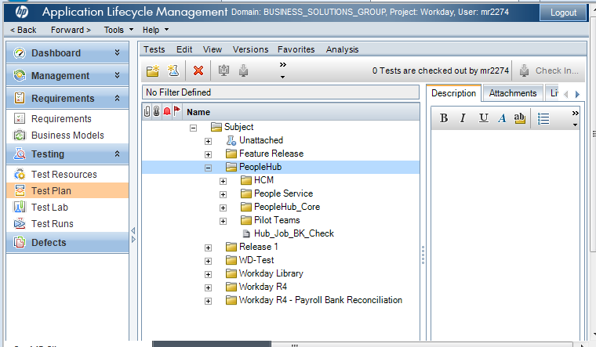

- HCM: This folder contains all the test cases to verify that changes made to source are reflecting in the target system like create a new cost center, update the existing cost center, terminate an employee etc.
- People Service: This folder contains all the test cases that are managed by People service team.
- PeopleHub_Core: This folder contains all the test cases that are centrally managed by PeopleHub Team.
- Pilot Teams: This folder contains test cases that are specific to individual pilot teams.
Test Lab:
The Test Lab Module is where all the test cases are run manually to locate defects and assess quality of the application. All the test cases are organized based on Releases.
- Release 1
- Release 2
- Release 3

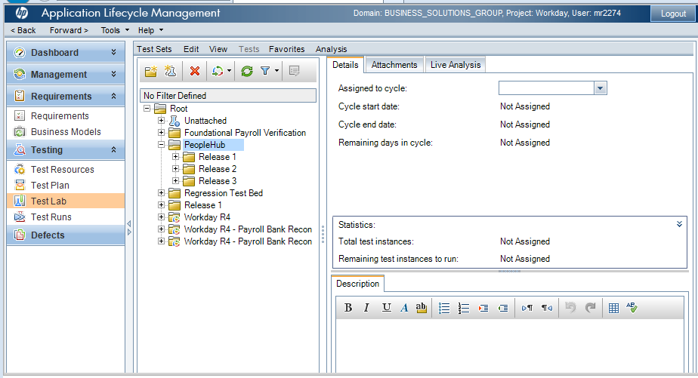

Events/Discoveries/Questions
- Client/desktop version of SVN(Tortoise) may have caused the server repository corruption having established a recursive versioning of Talend project folders on multiple clients.
  - Can the client version be configured to ignore server managed objects(Talend project folders)?
- SVN repository has 3 days back-up.
  - Is 3 days enough time to discover and react to possible repository issues? Should this be extended?
- Do we have the tools to identify/monitor corrupted code?
  - Can these data quality checks be automated?
svnadmin verify REPOS_PATH
- Does SVN allow for point in time full project recovery?
  - Do we have tested procedures and guidelines for different types of object recovery?
- Are there Talend repository data quality checks available?
  - A build may not show all possible errors.
- What is the popularity of this subject?
- Google search on "Recovering from Corrupted Revisions in an SVN Repository" returned 400,000 results.
- Google search on "Recovering from Corrupted Revisions in a GIT Repository" returned 1.7m results.
- Google search on "admissions to Yale university" returned 1.2m results.

Workday@Yale

People Hub Release Note – November 2016

How to Connect
We have a test SQL server setup for impacted systems to connect and remediate their systems.
SQL Server Name: aw-dwdev-01.yu.yale.edu
Database: DV_PeopleHub_TEST
Login Username/Password: Once access form is approved, Service Now ticket has to be submitted to create an account in PeopleHub.

Source of Data
PeopleHub is currently getting data from two sources. They are as follows:
- IAM Identity Management System – Data is from the DEV environment. Data was last loaded on 10/31/2016. There won’t be any incremental load for this release of PeopleHub.
- Workday – Data is from Yale3 (P2) instance. Data was last loaded on 10/31/2016. There won’t be any incremental load for this release of PeopleHub.

Population
PeopleHub population include Students, Employees, Contingent Workers, Academic Affiliates and Sponsored Identity. For this test release, we only have current last record for each UPI. Hence the following condition applies:
- Student records from IDR
- Current last record of student workers from Workday
- Current last record of Academic Affiliates from Workday
- Current last record of Employees from Workday (Includes active, on leave, terminated, retired employees and future employees)
- Current last record of Contingents workers from Workday (Includes active, on leave, terminated, retired contingent workers and future contingent workers)
- Current last record of Sponsored Identities from IDR

Data Dictionary
PeopleHub currently has 337 attributes. This includes Identity data, addresses, student enrollment, position, job, compensation, academic appointments and affiliations. The split of attributes by source is as follows:
- 243 from Workday
- 94 from IDR (Identity System, it included all banner data we are getting for now)
Data dictionary is available in the Impacted Systems website:
Impacted Systems -> People Data Information -> Technical Information on People Hub Structure -> People Hub Data Dictionary
Mapping of Legacy People Data Attributes to post Workday R4 Data is also available in the Impacted Systems Website:
Impacted Systems -> People Data Information -> Overview of People Hub Documents, Requesting Access and Transition Information -> People Data Mapping Rules

Views
PeopleHub currently have the following views:
- YUPH_PEOPLE_GENERAL_CUR_RSET_V
- YUPH_ACADEMIC_APPT_CUR_RSET_V
- YUPH_POSITIONS_CUR_RSET_V
- YUPH_ENROLLMENT_CUR_RSET_V
- YUPH_COST_CENTER_FLAT_V
- YUPH_COST_CENTER_HIER_V
- YUPH_ACADEMIC_UNIT_FLAT_V
- YUPH_SUPERVISORY_ORG_FLAT_V
Details documentation on these views are available in the Impacted Systems website:
Impacted Systems -> People Data Information -> Technical Information on People Hub Structure -> People Hub Integration Views

Security
PeopleHub ABAC row level and column level security is implemented on views with names ending with RSET_V. This security is based on the access form filled out by each team. Row level security is based on specific affiliation of population requested in the access form. Column level security is based on the data grouping requested in the access form.

Testing
All test cases are uploaded into ALM in the Testing folder.
This folder has two modules:
- Test Plan
- Test Lab
Tests that needs to carried out by pilot teams will be emailed to them as an Excel file. Pilot teams will need to execute these test cases and report the result back to the PeopleHub team in the same excel file. PeopleHub team will update the ALM with the test results.
Test Plan:
The Test Plan Module is where all the test cases for an application will be created and stored to test the quality of the application.
All the test cases are uploaded in PeopleHub folder under Subject.

- HCM: This folder contains all the test cases to verify that changes made to source are reflecting in the target system like create a new cost center, update the existing cost center, terminate an employee etc.
- People Service: This folder contains all the test cases that are managed by People service team.
- PeopleHub_Core: This folder contains all the test cases that are centrally managed by PeopleHub Team.

- Pilot Teams: This folder contains test cases that are specific to individual pilot teams.

Test Lab:
The Test Lab Module is where all the test cases are run manually to locate defects and assess quality of the application.

All the test cases are organized based on Releases.
- Release 1
- Release 2
- Release 3

How to Report Defects
We are keeping track of defects using ALM. Please use the link below to connect to ALM. Use IE to connect.
https://hpalm.its.yale.edu/qcbin/start_a.jsp

To view defects:
Once logged in:
- Select Defects from left side tab
- Select Favorite - > Public -> PeopleHubPilot
To enter defects:
Once logged in:
- Select New Defect
- Specify the following:
  - Assigned To:
  - Type:
  - Priority:
  - Description:
  - Detected in Cycle: Releases -> PeopleHub -> Release 1 -> Pilot
- Submit

Issues Addressed in this Release
We have added, removed and modified several attributes in PeopleHub. Several issues reported as part of the pilot testing are also addressed in this release. The issues raised by the pilot teams in ALM are assigned back to the team to have it re-tested. Please re-test them and report the status back in ALM.
Detailed documentation on issues addressed in this release are available in Box folder:
PeopleHubIssuesAddresedForRel2.xlsx –
https://workday.yale.edu/sites/default/files/files/People Hub Issues Addresed-Nov2016.xlsx

Workday@Yale

People Hub Release Note – September 2016

How to Connect
We have a test SQL server setup for PeopleHub pilot team to test.
SQL Server Name: aw-dwdev-01.yu.yale.edu
Database: DV_PeopleHub_TEST
Login Username: Please see table below. These are domain accounts and hence needs Windows authentication.
Password: New passwords will be send via Yale file transfer to the contact in the table below.

Department | Account Type | Account Name | Contact
IRES | Service Account | s_ph_ires_its | Rolfe, Elizabeth
YBT | Service Account | s_ph_ybt_fin | Fielding, Steve
Banner | Service Account | s_ph_banner_its | DeSalvatore, Michael
Facilities | Service Account | s_ph_fet_its | Haberman, Barbara
Law School | Service Account | s_ph_inside_law | Grow, Abigail and Alli, Syed
Message III | Service Account | s_ph_msgIII_its | Gloria Hoda, Venkat Reddy and Dave DeMichele
Darrell's Team | Service Account | s_ph_soa_its | Kitz, Marissa and Viele, Christine

Source of Data
PeopleHub is currently getting data from two sources. They are as follows:
- IAM Identity Management System – Data is from the DEV environment. Data was last loaded on 8/30/2016. There won’t be any incremental load for this release of PeopleHub.
- Workday – Data is from Yale3 (P2) instance. Data was last loaded on 8/30/2016. There won’t be any incremental load for this release of PeopleHub.

Population
PeopleHub population include Students, Employees, Contingent Workers and Affiliates. For this test release, we only have latest current record for each individual. Hence the following condition applies:
- Student records from IDR
- Latest current records of student workers from Workday
- Affiliates from Workday
- Latest current record of Employees (Includes active, on leave, terminated and retired employees)
- Latest current record of Contingents workers (Includes active, on leave, terminated and retired contingent workers)
- Sponsored Identities (Only identity attributes from IDR)

This release does not include:
- Future Employees or Contingent Workers

Data Dictionary
PeopleHub currently has 331 attributes. This includes Identity data, addresses, student enrollment, position, job, compensation, academic appointments and affiliations. This version does not include Sponsored Identity (other than identity attributes), Faculty Information System related data from Banner and Committee System. The split of attributes by source is as follows:
- 245 from Workday
- 76 from IDR (Identity System, it included all banner data we are getting for now)
- 10 from ACS1 yuonlinedir.CONFIDENTIAL_EMAIL_FLAGS in Oracle (This is confidentiality flags for Message III, we have this in dictionary but has not yet done the load. Will be doing it in the next week or so.)
Data dictionary is available in the Impacted Systems website:
Impacted Systems -> People Data Information -> Technical Information on People Hub Structure -> People Hub Data Dictionary
Mapping of Legacy People Data Attributes to post Workday R4 Data is also available in the Impacted Systems Website:
Impacted Systems -> People Data Information -> Overview of People Hub Documents, Requesting Access and Transition Information -> People Data Mapping Rules

Views
PeopleHub currently have the following views:
- YUHR_PEOPLE_GENERAL_CUR_RSET_V
- YUHR_ACADEMIC_APPT_CUR_RSET_V
- YUHR_POSITIONS_CUR_RSET_V
- YUHR_ENROLLMENT_CUR_RSET_V
- YUHR_COST_CENTER_FLAT_V
- YUHR_COST_CENTER_HIER_V
- YUHR_ACADEMIC_UNIT_FLAT_V
- YUHR_SUPERVISORY_ORG_FLAT_V
Details documentation on these views are available in the Impacted Systems website:
Impacted Systems -> People Data Information -> Technical Information on People Hub Structure -> People Hub Integration Views

Security
PeopleHub ABAC row level and column level security is implemented on views with names ending with RSET_V. This security is based on the access form filled out by each team. Row level security is based on specific affiliation of population requested in the access form. Column level security is based on the data grouping requested in the access form.

How to Report Defects
We are keeping track of defects using ALM. Please use the link below to connect to ALM. Use IE to connect.
https://hpalm.its.yale.edu/qcbin/start_a.jsp
To view defects:
Once logged in:
- Select Defects from left side tab
- Select Favorite - > Public -> PeopleHubPilot
To enter defects:
Once logged in:
- Select New Defect
- Specify the following:
  - Assigned To:
  - Type:
  - Priority:
  - Description:
  - Detected in Cycle: Releases -> PeopleHub -> Release 1 -> Pilot
- Submit

