Workday@Yale

COA Integration Hub Connections – SQL Server to COA Integration Hub (Linked Server)

Overview
This guide defines the guiding principle to utilize when a system needs to connect from a SQL Server Database to COA Integration Hub. This technique should be utilized when you have an existing Linked Server connection to another SQL Server Database that has access to COA information should now to come from COA Integration Hub.

What You Need to Know
The COA Integration Hub is located on a SQL Server Database. The guiding principle to access data from the COA Integration Hub is to utilize a Web Service Consumer to request COA Segment Information from this store. In situations where the time to convert an existing application to utilize the Web Service approach to get data will not allow to meet business deliverables then JDBC/ODBC is preferred. In cases where that is not possible then the Linked Server approach can be utilized to get information efficiently.

Additional Information
1. SQL Server Management Studio should be used to set up this connection

The Server name entered will be the exact server database name of the COA Integration Hub Server.

- You can create multiple connections to the same linked server. The steps for this are outlined in the Frequently Asked Questions Section (FAQ)

Server Information
Server Names
Development: sql-cludevlsnr.its.yale.internal
Test: sql-clutstlsnr.its.yale.internal
Production: sql-cluprdlsnr

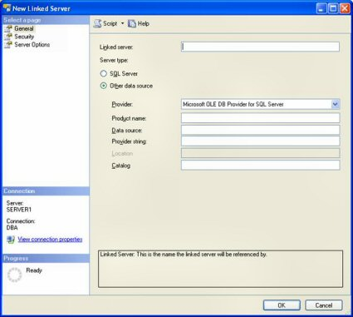
Define a Linked Server
How to Define a Linked Server

To create or list the available linked servers already defined you look under the “Server Objects” folder within SQL Server Management Studio (SSMS).
First expand the “Server Objects” folder, and then right click on the “Linked Servers” item. This would display the following window:

For help contact: workday@yale.edu and include the title of this guide in the email message.
Revised 02/24/17 Or visit the Workday COA Link Here website. 1 | 2

Workday@Yale

COA Integration Hub Connections – SQL Server to COA Integration Hub (SQL Server)

On this window, name your new linked server and identify the type of data source your linked server will be. We will use “Server Name”, as a SQL Server data source. In order to do that we will need to identify the name of the linked server and then use the “Security” and “Server Options” pages to define how we would like to authenticate to the COA Integration Hub linked server and what options will be associated with my linked server. To begin defining the linked server we enter “Server Name” in the “Name” field and then click on the “SQL Server” radio button to identify that my new linked server is a SQL Server data source. The Linked Server name must be the server name of the COA Integration Hub.

When we do this your window looks like this

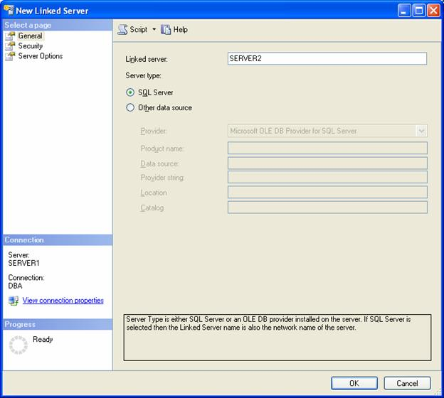

To define how clients would authenticate to “Server Name” click on the “Security” item, the following page is displayed:

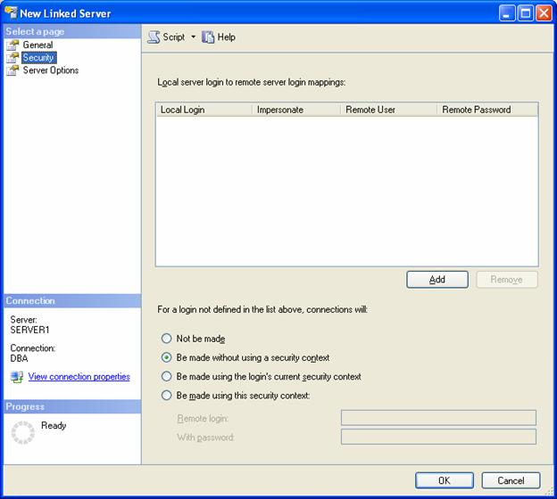

For help contact: workday@yale.edu and include the title of this guide in the email message.
Revised 02/24/17 Or visit the Workday COA Link Here website.
Workday@Yale

COA Integration Hub Connections – SQL Server to COA Integration Hub (SQL Server)

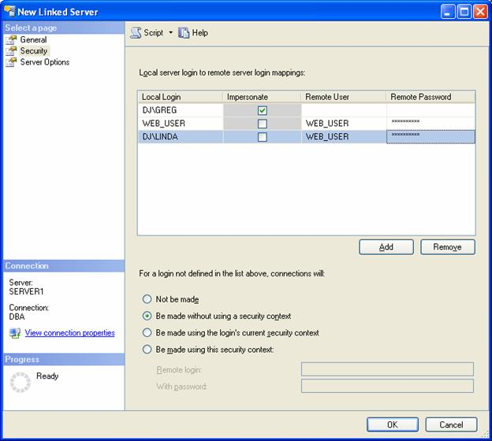
Map Local login to Remote Login
COA Integration Hub has a set of user logins/accounts that have been set up for each impacted system. In order for the linked server to utilize the correct login we must map the local login to the Remote User login. This is accomplished by selecting the Security Page on the New Linked Server Dialog.
First click on the add button and then add the local login account to the Remote User. The Remote user will be the name of the system account that was given to you by the security team to access COA Integration hub. Also add the password for this account into the Remote Password field.
Local Login: YALE\s_coa_tst_its
Remote User: s_coa_tst_its

COA Integration Hub Connections – SQL Server to COA Integration Hub (SQL Server)

TSQL Examples for Using Linked Servers

I defined a linked server named “dev-sqlag2-lsnr.YU.YALE.EDU”. As stated earlier, in order to reference objects on “dev-sqlag2-lsnr.YU.YALE.EDU” I would need to use a four-part naming convention. Below are some examples of how to referencing objects on dev-sqlag2-lsnr.YU.YALE.EDU.

Here is how you can retrieve information in the “COA_Company_V” table in the “WDIntegrationHubDev” databases stored on linked server “dev-sqlag2-lsnr.YU.YALE.EDU”:

SELECT * FROM dev-sqlag2-lsnr.YU.YALE.EDU.WDIntegrationHubDev.dbo.COA_Company_V

All you have to do here is put the linked server name followed by a period before the fully qualified table name.

For help contact: workday@yale.edu and include the title of this guide in the email message.
Revised 02/24/17 Or visit the Workday COA Link Here website.
1 | 2

Workday@Yale

COA Integration Hub Connections – Talend to COA Integration Hub (JDBC)

Overview
This section defines the guiding principle to utilize when a system needs to connect external systems with the COA Integration Hub. Utilizing Talend as the integration tool for system access with the COA Integration hub is the preferred approach. Ultimately, the guiding principle is to utilize Talend’s Web Service components to connect to the COASegmentService to extract information from the COA Integration Hub. This document however outlines the Talend JDBC approach for access. This technique should be utilized when there is a need for information from the COA Integration Hub and the COA Segment Services that are needed does not cover the COA Segment attributes that are needed by your system. It is still recommended that you reach out to the Service team to give your business requirements and attribute needs that are not available via the COA Integration Hub Access Request form so that the team can look into creating or augmenting existing services to meet your need.

What You Need to Know
The COA Integration Hub is located on a SQL Server Database. The guiding principle to access data from the COA Integration Hub is to utilize a Web Service Consumer to request COA Segment Information from this store. In situations where the time to convert an existing application to utilize the Web Service approach to get data will not allow to meet business deliverables the Talend JDBC approach can be utilized to get information efficiently.

Additional Information
1. Talend Studio (v6.2x)

- Login account and password for access to the COA Integration Hub

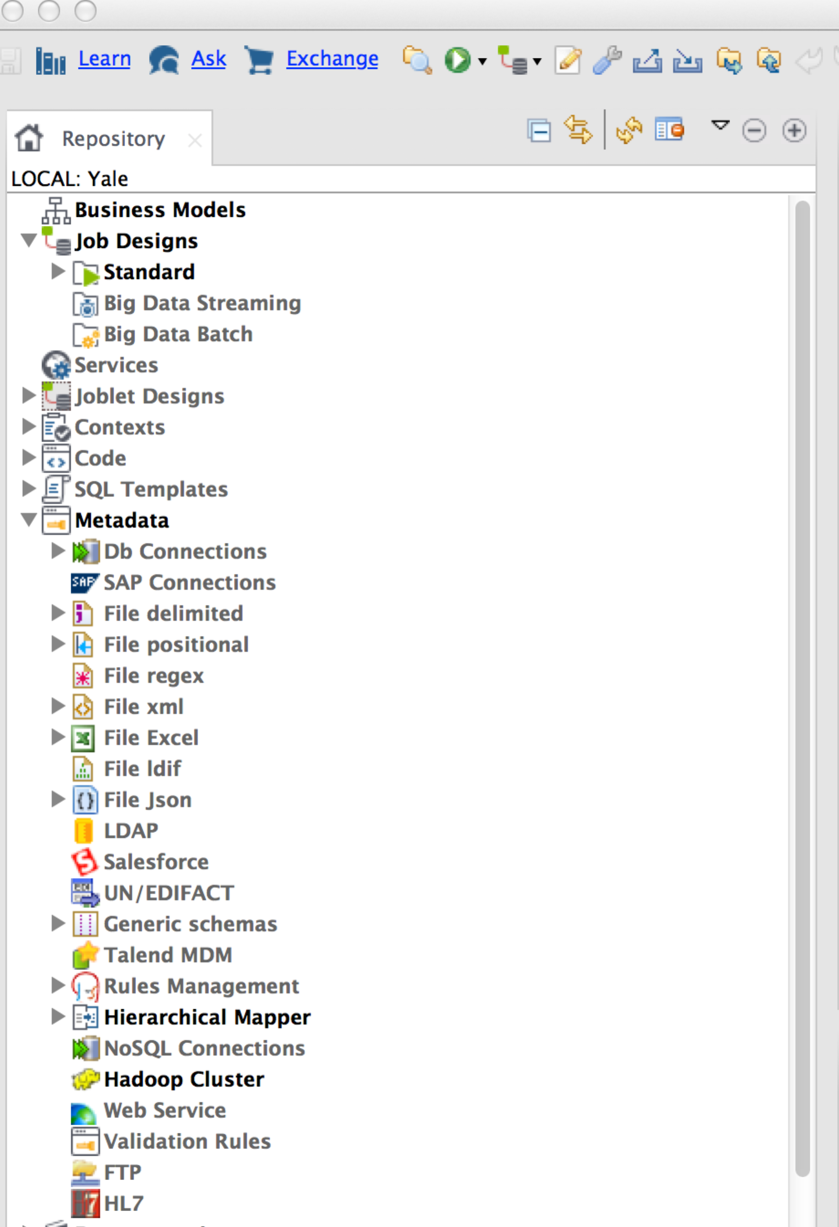

Create Metadata Connection

First thing that must be set up in Talend Studio is a metadata connection to the COA Integration Hub Server. The metadata connection is located on the left hand side of your Talend Workspace in the Integration perspective.
Expand the Metadata node.
In order to establish a connection to COA Integration Hub on SQL Server, right click on the Db Connections. In the context menu click Create connection. This will open the Database Connection Wizard.

For help contact: workday@yale.edu and include the title of this guide in the email message.
Revised 02/24/17 Or visit the Workday COA Link Here website. 1 | 2

Workday@Yale

COA Integration Hub Connections – Talend to COA Integration Hub (JDBC)

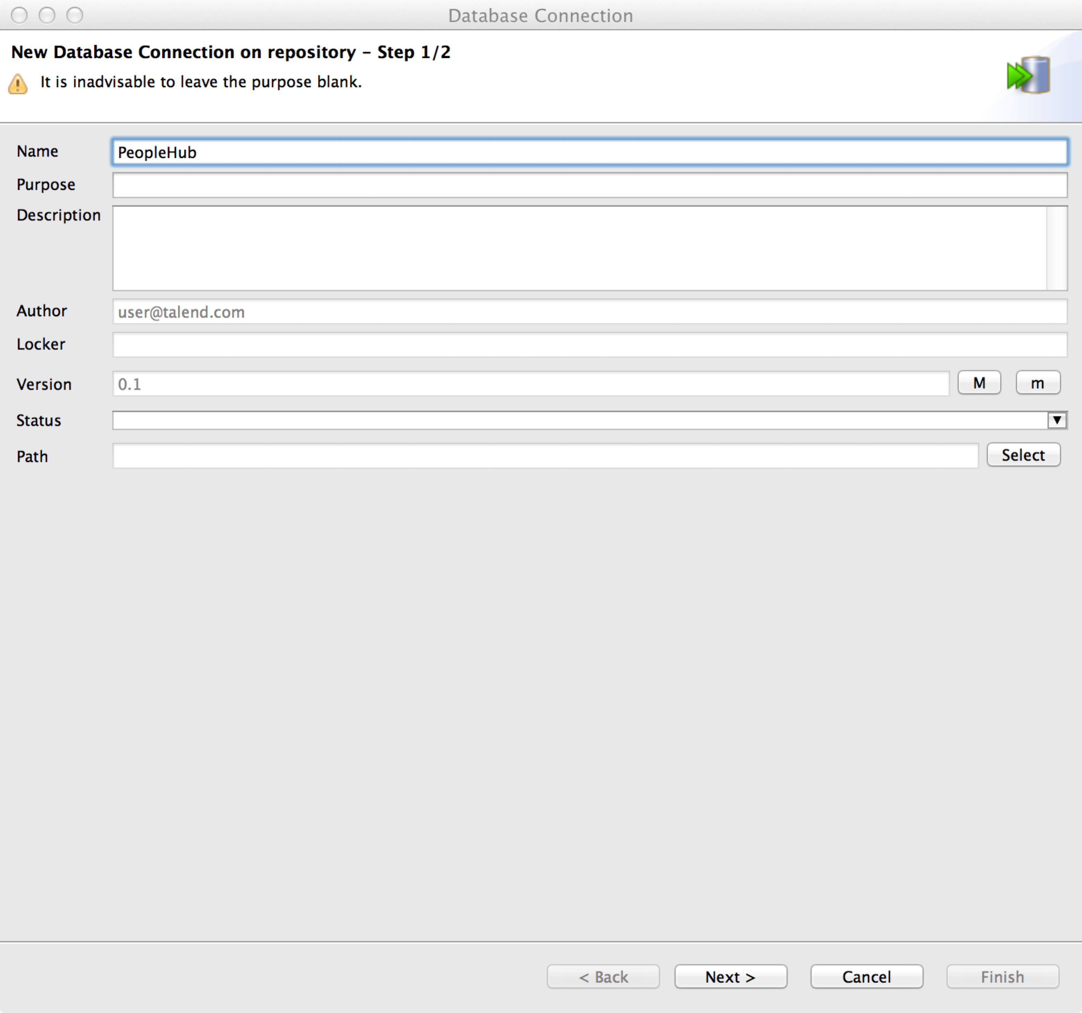
Database Connection Wizard
The database connection wizard will walk you through setting up your connection to COA Integration Hub (SQL Server). First enter the name you want to define for your connection. In this example we have entered COAIntegrationHub.
Once entered, click Next. Step 2/2 of the wizard dialog will display. This is where we enter the login credentials that were given for your system to access COA Integration Hub.
Enter your login id in the Login field (i.e dev-sqlag2-lsnr.YU.YALE.EDU).
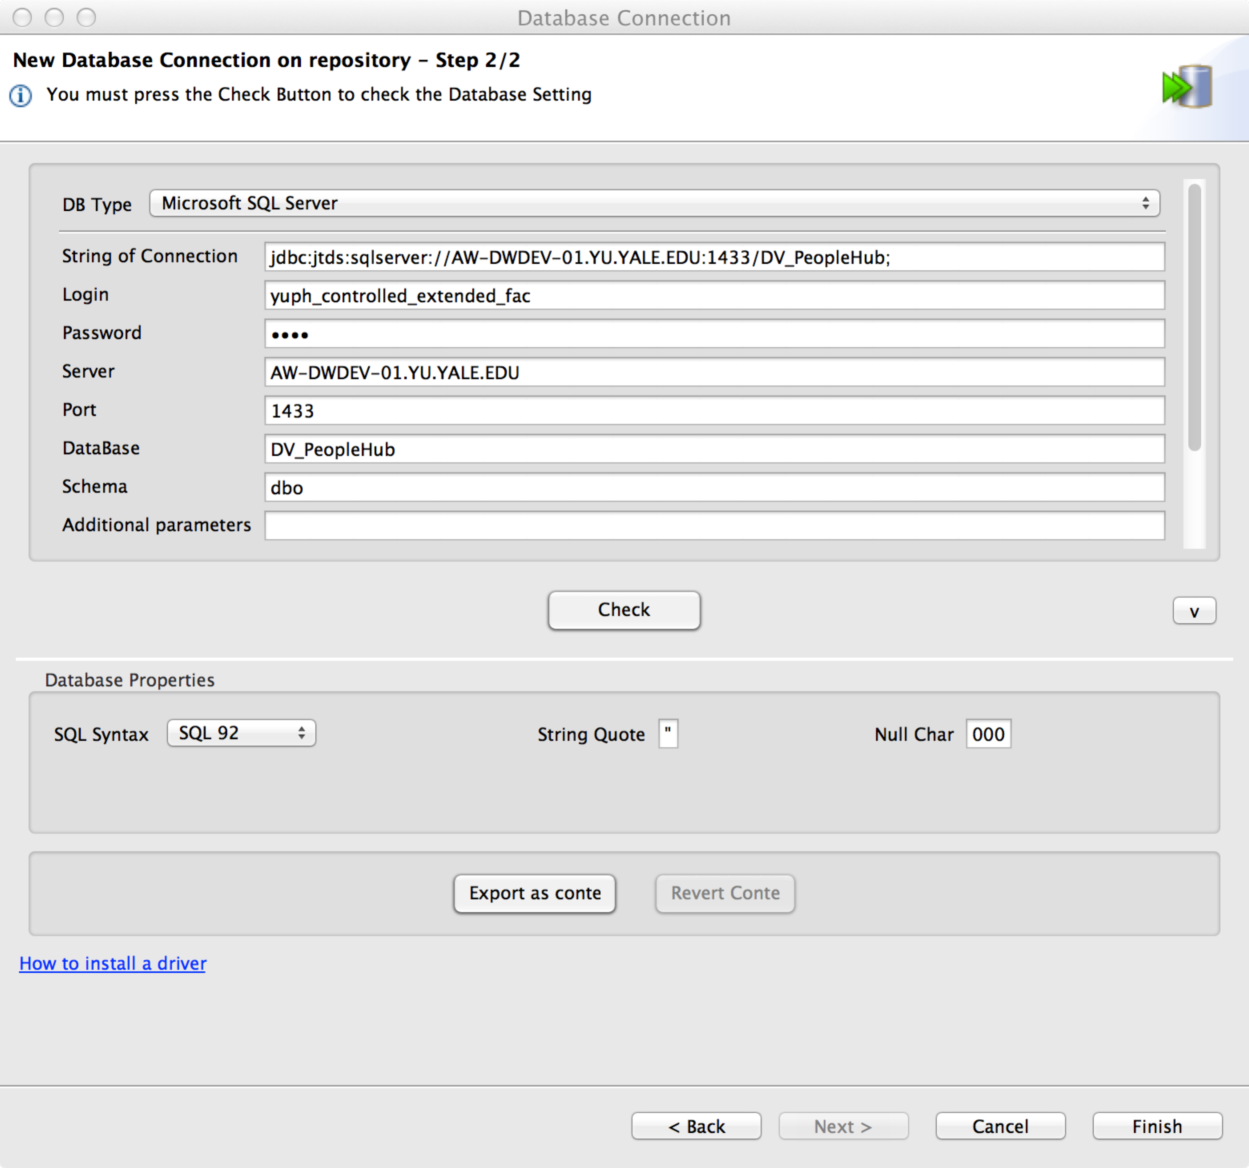
Enter your password next in the password field. The password entry is masked by * when you type.
Next enter the port to COAIntegrationHub, currently set as 1433.
Next will be the DataBase for the COA Integration Hub: WDIntegrationHubDev
Next, enter the Schema: dbo
You can check to see if the connection information you entered is valid by clicking on the Check Button. If all is well, you should see the Connection Successful Dialog. Click OK and then Click Finish to close the wizard and create the new connection.
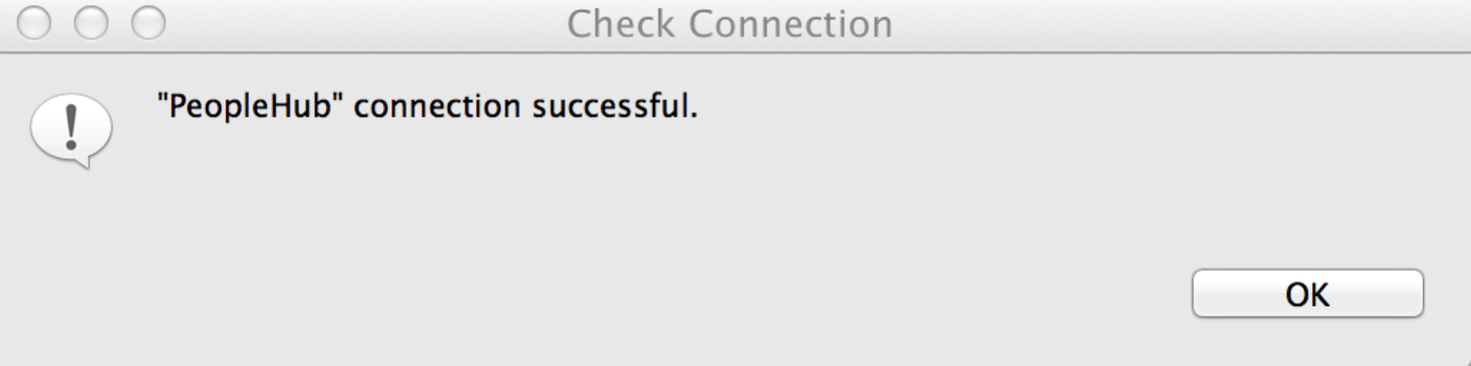
In the Repository view on the left side the new connection will appear under the Metadata-> Db Connections node.
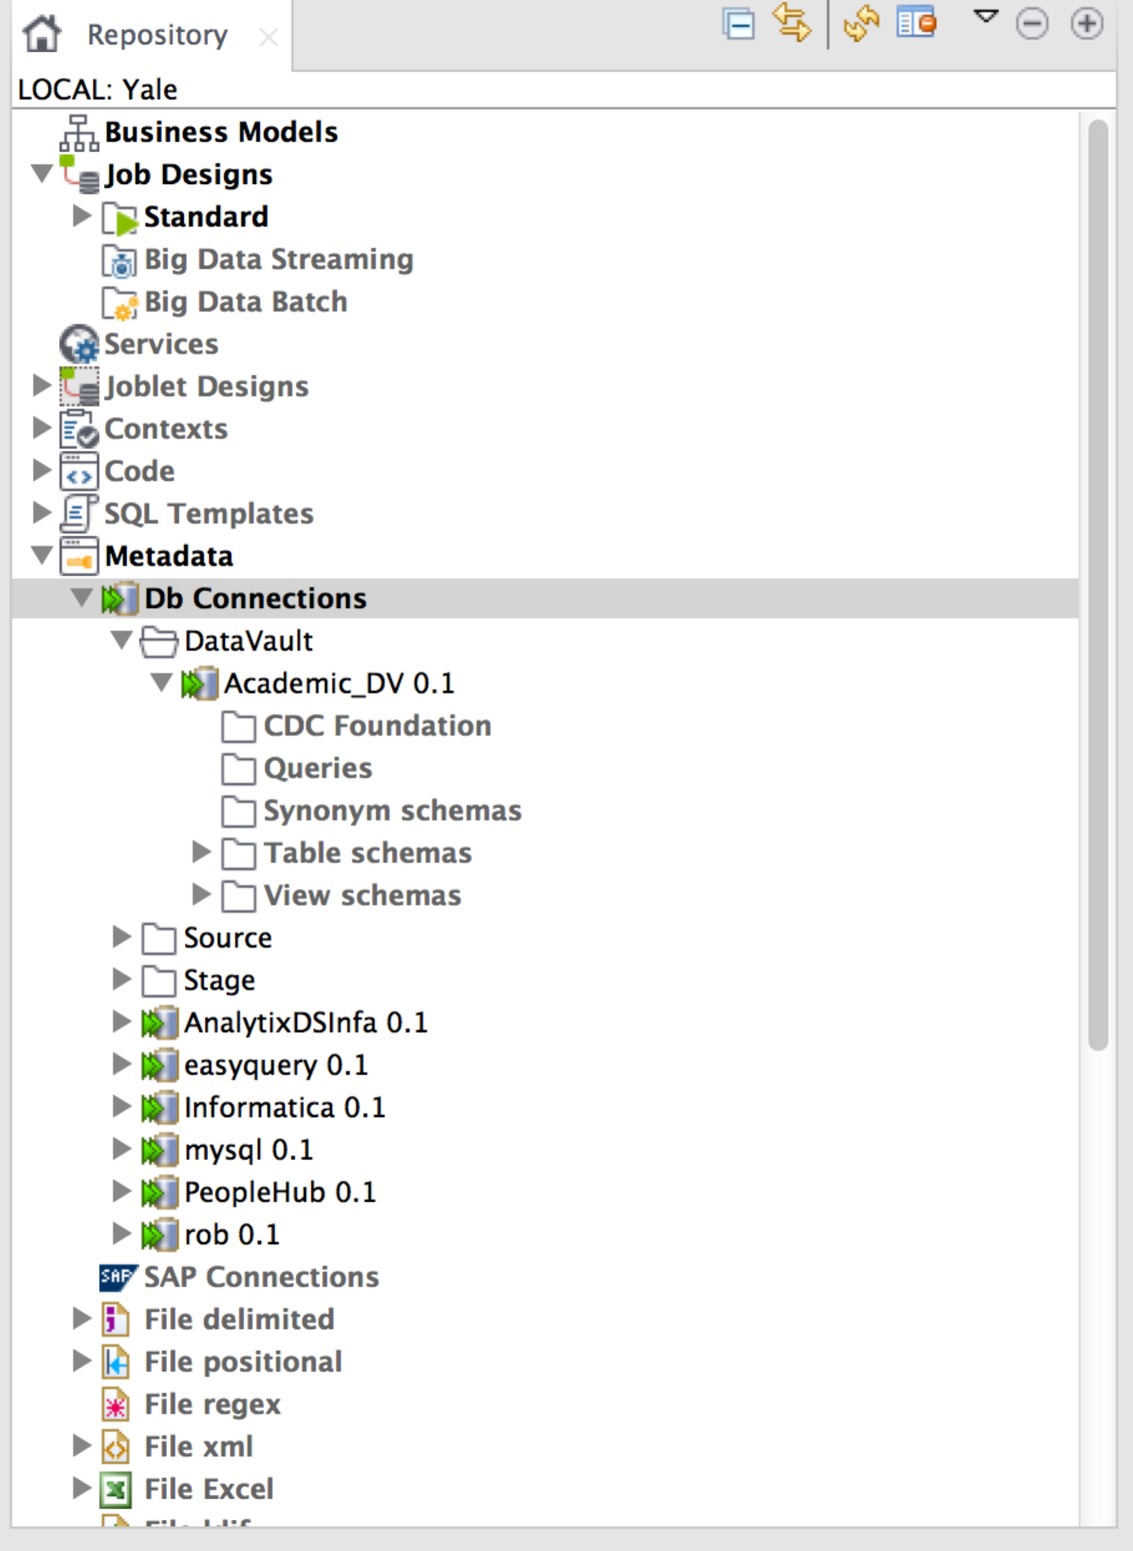

Workday@Yale

COA Integration Hub Connections – Talend to COA Integration Hub (JDBC)

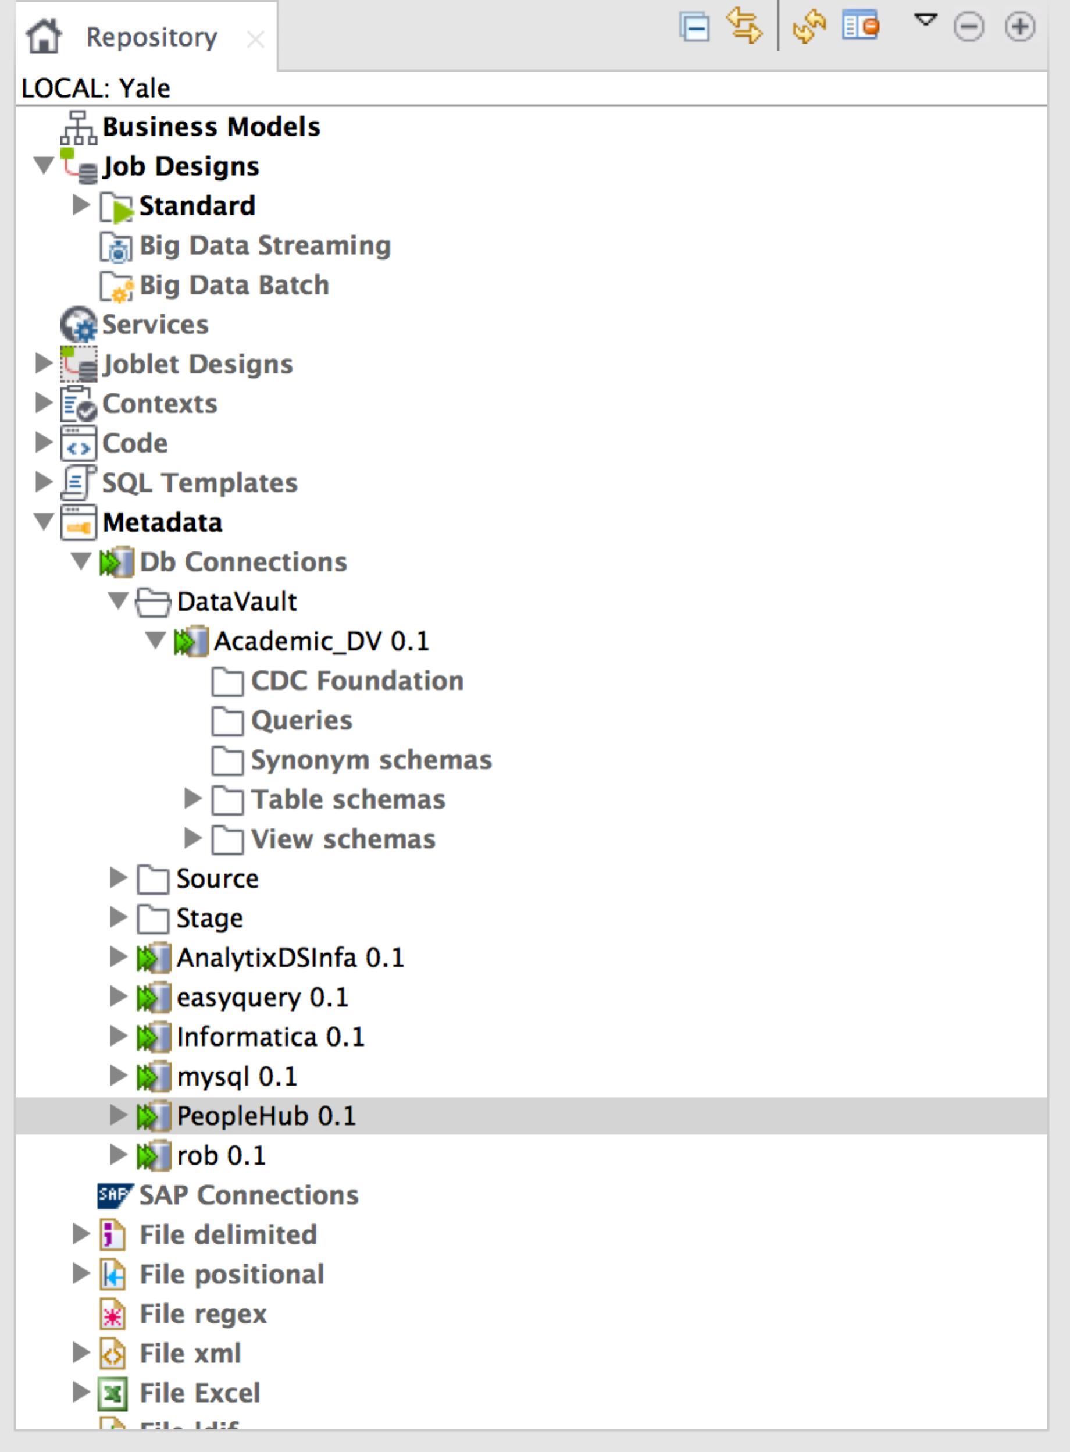
Retrieve COA Integration Hub View Schemas from the COAIntegrationHub DB Connection Metadata
Create a Table schema metadata
In the Repository on the left of the Talend Open Studio main screen:
Expand the Metadata > RemoteDBMS node.
Right-click on COAIntegrationHub.
In the menu, click Retrieve Schema to open the Schema wizard.
The Default selections for Select Types should be changed to check VIEW only. At this point we can just click Next in order to get the list of COA Integration Hub views that we would like to set up within Talend to use in our jobs (see below).
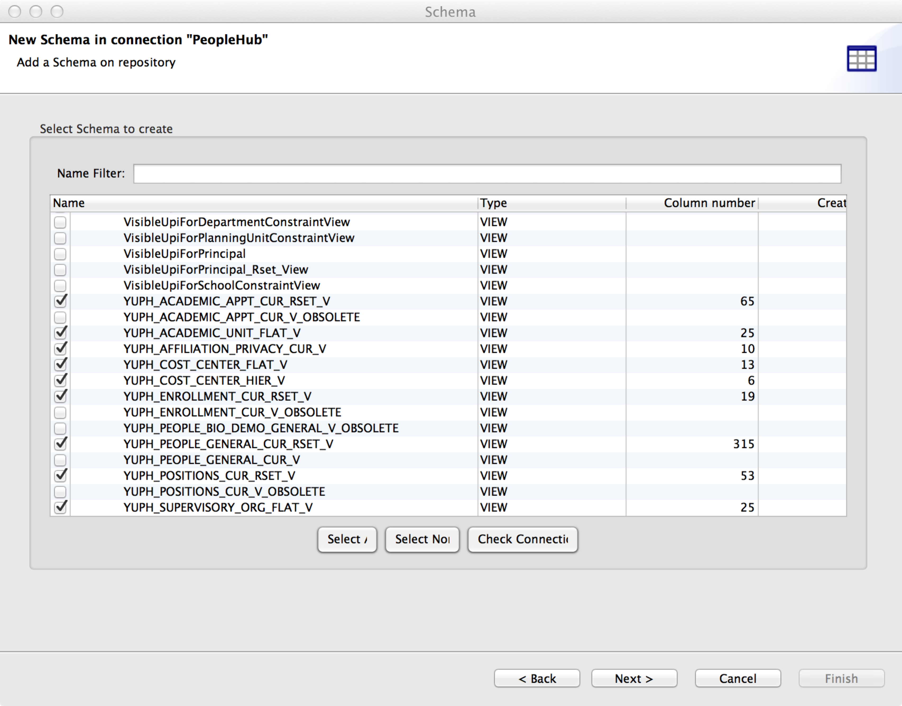

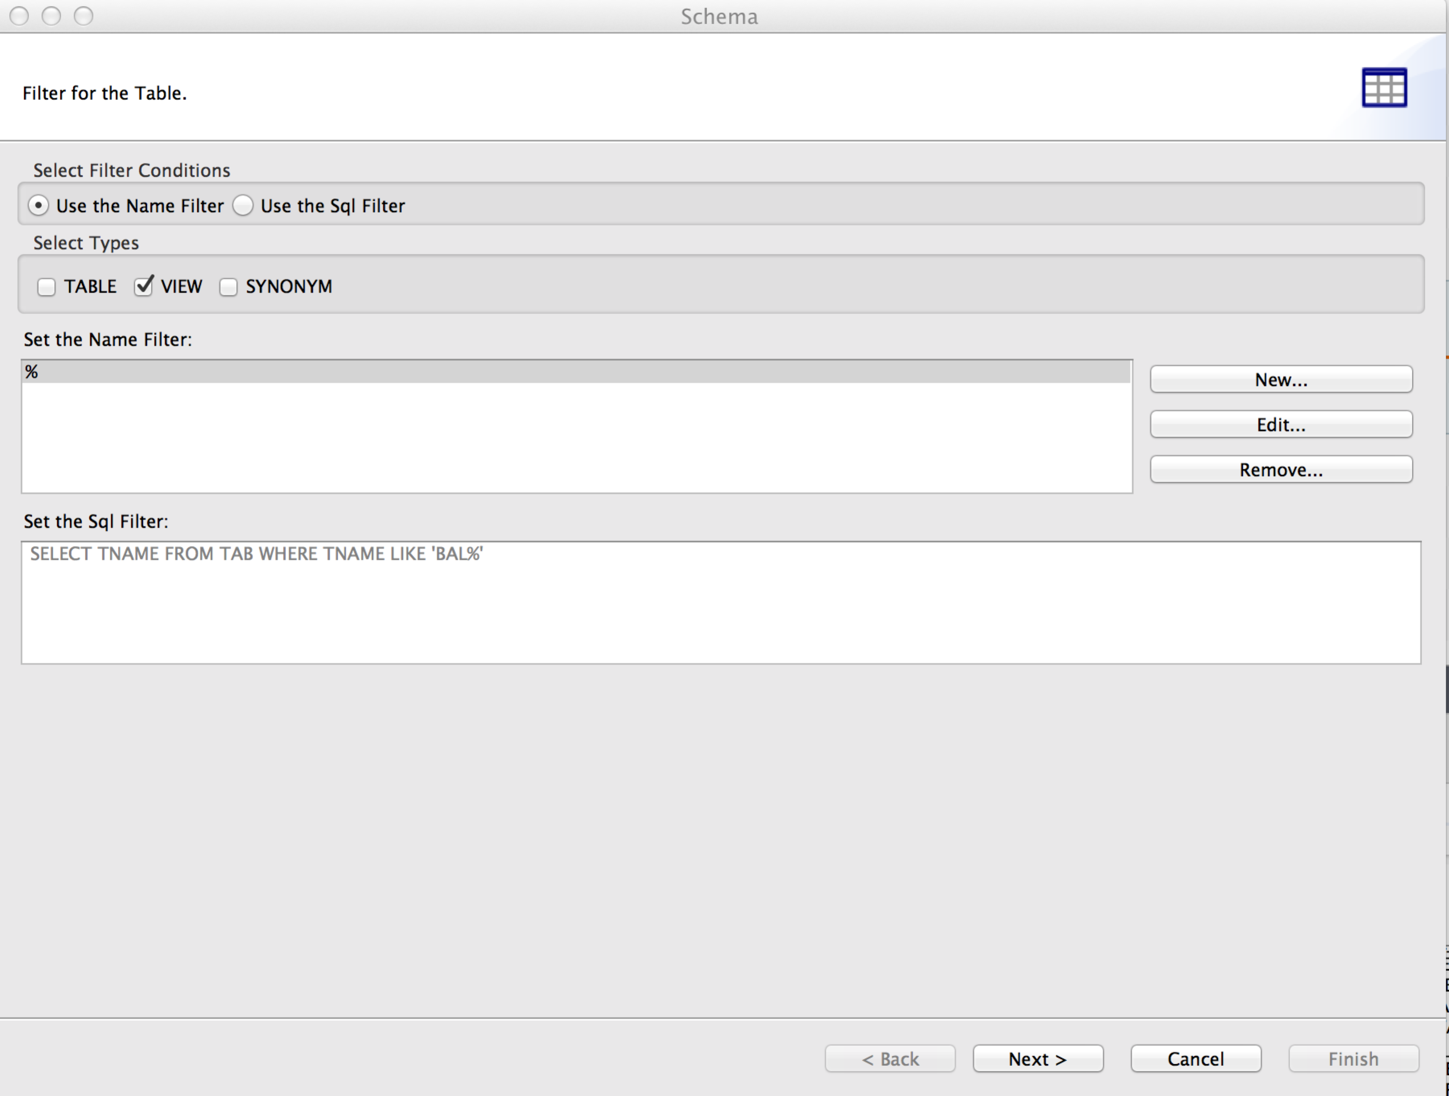

Once Selected click Next:

Workday@Yale

COA Integration Hub Connections – Talend to COA Integration Hub (JDBC)

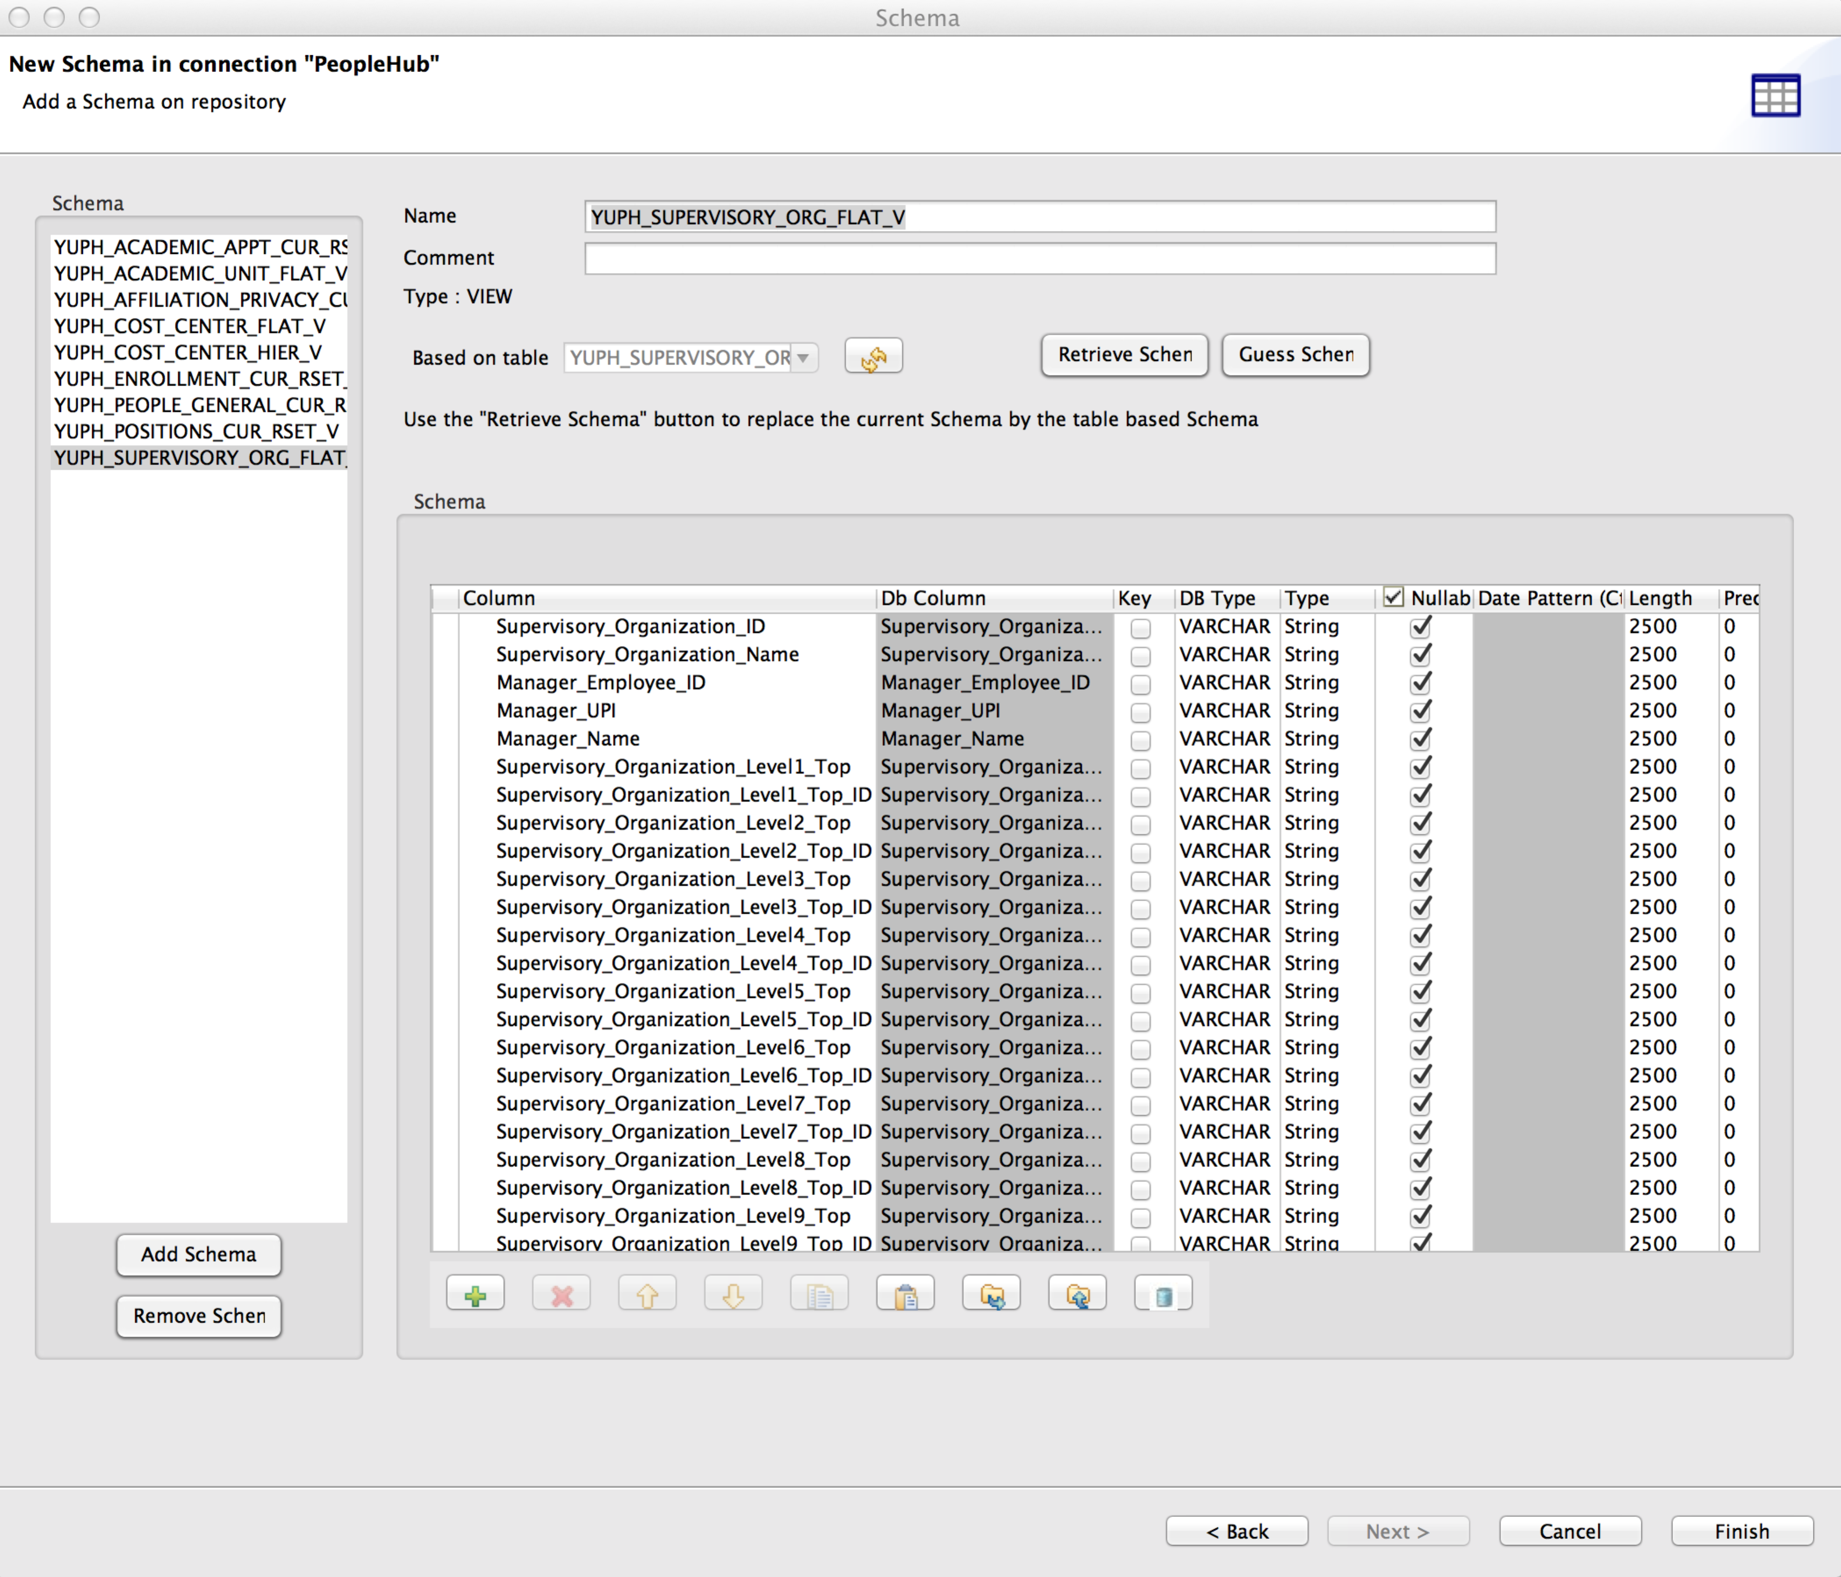
Talend Imported Views Schema Wizard

You now see a list of the selected COA Integration Hub Views along
with their associated schema definitions. You can modify the
structure (i.e.Key, Db Type, Type, Nullable, etc) if needed. Once
completed click Finish. This will bring you to the main Talend
workspace with the Repository on the left side. In the Repository
view you can select Metadata->Db Connections->COAIntegrationHub->
View Schemas

You will see the list of COA Integration Hub Views that can now be
used in your Talend jobs.

